ELLIPTIC CURVE ARITHMETIC TOOLS USING SAGEMATH AND PROJECT HOSTING GATEWAY
Project report submitted
in partial fulfilment of the requirement for the degree of
Bachelor of Engineering in Information Technology
By
Aditya Chowdhury (002211001133)
Lekharshav Sengupta (002211001121)
Rounak Saha (002211001132)
Under the guidance of
Prof. Utpal Kumar Ray
Assistant Professor (Contractual)

Department of Information Technology,
Faculty of Engineering and Technology,
Jadavpur University, Salt Lake Campus
2025–2026

BONAFIDE CERTIFICATE
This is to certify that this project report entitled “ELLIPTIC CURVE ARITHMETIC TOOLS USING SAGEMATH AND PROJECT HOSTING GATEWAY” submitted to Department of Information Technology, Jadavpur University, Salt Lake Campus, Kolkata, is a bonafide record of work done by Aditya Chowdhury (Registration No: 163328 of 2022-2023), Lekharshav Sengupta (Registration No: 163316 of 2022-2023), and Rounak Saha (Registration No: 163327 of 2022-2023) under my supervision from 01.07.2025 to 01.06.2026.

Prof. Utpal Kumar Ray
Assistant Professor (Contractual)
Department of Information Technology

Countersigned By:

Prof. Bhaskar Sardar
Head of Department
Department of Information Technology

Place: Kolkata
Date: 01.06.2026

DECLARATION
We hereby declare that this report is an original work prepared entirely by us. It contains no plagiarised content from external sources. Wherever information, ideas, algorithms, software tools, or documentation from external origins have been used, the same has been duly acknowledged through proper citations and references. We acknowledge our accountability in the event of any detected plagiarism. This work has not been submitted elsewhere for the attainment of any other academic degree or diploma.

Aditya Chowdhury
Roll No. 002211001133

Lekharshav Sengupta
Roll No. 002211001121

Rounak Saha
Roll No. 002211001132
Place: Kolkata
Date: 01.06.2026
ACKNOWLEDGEMENTS
We express our sincere gratitude to Prof. Utpal Kumar Ray, Assistant Professor (Contractual), Department of Information Technology, Jadavpur University, for his guidance, encouragement, and technical direction throughout the project. His patient mentorship and biweekly review sessions were instrumental in keeping the project on track and ensuring both mathematical rigour and engineering correctness.
We are grateful to Prof. Bhaskar Sardar, Head of Department, Department of Information Technology, for providing the administrative support, computing infrastructure, and academic environment necessary to carry out this work.
We thank the Department of Information Technology and Jadavpur University for access to the software laboratories and the academic resources required to design, implement, test, and document the project.
We acknowledge the open-source communities behind SageMath, Flask, Werkzeug, Docker, and Python. Their tools made it possible to combine exact mathematical computation with a browser-accessible web interface that is both reproducible and deployable on public cloud infrastructure.
We also thank our families, classmates, and seniors for their encouragement and support during the implementation and documentation phases of this project.

Department of Information Technology
Jadavpur University, Salt Lake Campus, Kolkata

Aditya Chowdhury
Roll No. 002211001133

Lekharshav Sengupta
Roll No. 002211001121

Rounak Saha
Roll No. 002211001132


JADAVPUR UNIVERSITY
Dept. of Information Technology
Vision:
To provide young undergraduate and postgraduate students a responsive research environment and quality education in Information Technology to contribute in education, industry and society at large.
Mission:
M1: To nurture and strengthen professional potential of undergraduate and postgraduate students to the highest level.
M2: To provide international standard infrastructure for quality teaching, research and development in Information Technology.
M3: To undertake research challenges to explore new vistas of Information and Communication Technology for sustainable development in a value-based society.
M4: To encourage teamwork for undertaking real life and global challenges.

Program Educational Objectives (PEOs):
Graduates should be able to:
PEO1: Demonstrate recognizable expertise to solve problems in the analysis, design, implementation and evaluation of smart, distributed, and secured software systems.
PEO2: Engage in the engineering profession globally, by contributing to the ethical, competent, and creative practice of theoretical and practical aspects of intelligent data engineering.
PEO3: Exhibit sustained learning capability and ability to adapt to a constantly changing field of Information Technology through professional development, and self-learning.
PEO4: Show leadership qualities and initiative to ethically advance professional and organizational goals through collaboration with others of diverse interdisciplinary backgrounds.
Mission - PEO matrix:
Ms/ PEOs | M1 | M2 | M3 | M4
PEO1 | 3 | 2 | 2 | 1
PEO2 | 2 | 3 | 2 | 1
PEO3 | 2 | 2 | 3 | 1
PEO4 | 1 | 2 | 2 | 3
(3 – Strong, 2 – Moderate and 1 – Weak)
Program Specific Outcomes (PSOs):
At the end of the program a student will be able to:
PSO1: Apply the principles of theoretical and practical aspects of ever evolving Programming & Software Technology in solving real life problems efficiently.
PSO2: Develop secured software systems considering constantly changing paradigms of communication and computation of web enabled distributed Systems.
PSO3: Design ethical solutions of global challenges by applying intelligent data science & management techniques on suitable modern computational platforms through interdisciplinary collaboration.

ABSTRACT
This project presents two complementary academic deliverables for the 2025–2026 final-year project cycle at the Department of Information Technology, Jadavpur University.
Elliptic Curve Arithmetic (ECA) Tools is a SageMath-powered Flask web application for performing exact elliptic-curve computations over finite fields. The tool supports the general Weierstrass curve equation y² + a₁xy + a₃y = x³ + a₂x² + a₄x + a₆ over both prime fields GF(p) and extension fields GF(pⁿ). Operations include curve order calculation, enumeration of curve points and their orders, point addition, point subtraction, scalar multiplication, random non-singular curve generation, and optional visualisation for degree-one fields. All computation is delegated to SageMath scripts invoked via managed subprocesses with per-request timeout and replacement logic to prevent stale processes.
Project Hosting Gateway is a separate repository that provides a common homepage and mounts independent Flask applications under predictable /tools/<ToolName> routes using Werkzeug DispatcherMiddleware. In the current deployment, ECA Tools is mounted at /tools/ECA_Tools while remaining independently executable as a standalone application. The gateway also includes a Sample tool template to guide future project groups.
The implementation uses Python 3, Flask, SageMath, Werkzeug, Docker, Gunicorn, and Render for deployment. The standalone ECA Tools application is live at https://be-projects-2026.onrender.com . The system is both a mathematical calculator for elliptic-curve arithmetic and a reusable institutional hosting structure for future student-developed tools.
Keywords: Elliptic Curve Arithmetic, SageMath, Flask, Finite Fields, General Weierstrass Form, DispatcherMiddleware, Docker, Gunicorn, Render, Web Hosting, Cryptographic Education.

TABLE OF CONTENTS
1 Introduction 1
1.1 Background 1
1.2 Motivation 1
1.3 Objectives 1
1.4 Project Contributions 2
2 Basic Concepts and Technology Used 2
2.1 Finite Fields and Modular Arithmetic 2
2.2 Elliptic Curve Equation 2
2.3 Point Operations 3
2.4 Curve Order and Hasse Bound 3
2.5 Technologies Used 3
3 Review of Literature 4
4 Implementation and Results 6
4.1 System Architecture 6
4.2 ECA Tools Application 7
4.3 Request Management 13
4.4 Sample Computation 14
4.5 Functional Testing 14
4.6 Project Hosting Gateway 15
5 Performance Analysis 16
6 Boundaries of Current Work 17
7 Conclusion 17
8 Future Scope 18
Appendix I: How to Add a New Tool 19
Appendix II: Directory Structure 23
Appendix III: Sagemath Installation and Basic Elliptic Curve Commands 28
References 32

LIST OF SYMBOLS, ABBREVIATIONS AND NOMENCLATURE
Symbol / Abbreviation / Nomenclature | Definition
ECA | Elliptic Curve Arithmetic
ECC | Elliptic Curve Cryptography
GF(p) | Galois (finite) field of prime order p
GF(pⁿ) | Extension field of degree n over GF(p)
E(K) | Elliptic curve group defined over field K
O | Point at infinity; identity element of the elliptic-curve group
|E(K)| | Order of E over K; total number of points including O
a₁, a₂, a₃, a₄, a₆ | General Weierstrass coefficients for y² + a₁xy + a₃y = x³ + a₂x² + a₄x + a₆
SageMath | Open-source mathematical software system used for finite-field and elliptic-curve computation
Flask | Lightweight Python WSGI web framework used for routing and template rendering
DispatcherMiddleware | Werkzeug WSGI middleware that multiplexes requests to independent Flask apps by URL prefix
WSGI | Web Server Gateway Interface; Python standard for web server-application communication
Gunicorn | Green Unicorn: a production-grade WSGI HTTP server for Python web applications
Docker | Platform for building and running applications in isolated, reproducible containers
Render | Cloud platform used for public deployment of the containerised web service
Table 2. List of symbols, abbreviations and nomenclature

LIST OF FIGURES
Figure 1. Project Hosting Gateway and ECA Tools architecture diagram
Figure 2. ECA Tools computation pipeline
Figure 3. ECA Tools Home Page
Figure 4. Curve Order Input Form
Figure 5. Curve Order Result Page
Figure 6. Point Enumeration Input Form
Figure 7. Point Enumeration Output
Figure 8. Point Addition Interface
Figure 9. Point Addition Result
Figure 10. Scalar Multiplication Interface
Figure 11. Scalar Multiplication Result
Figure 12. Project Hosting Home Page
Figure 13. Mounted ECA Tools Through Gateway

LIST OF TABLES
Table 1. Mission – PEO matrix
Table 2. List of symbols, abbreviations and nomenclature
Table 3. Literature review and related work
Table 4. Gap analysis
Table 5. Point operation formulas and SageMath implementation map
Table 6. Technologies used
Table 7. Project repository map
Table 8. SageMath backend script map
Table 9. Functional testing matrix
Table 10. Performance and deployment observations

1. Introduction

1.1 Background
An elliptic curve over real numbers may be defined as the set of points (x, y) which satisfy an
elliptic curve equation of the form:
y² = x³ + ax + b,
where x, y, a and b are real numbers.
Elliptic curves over finite fields are used widely in modern public-key cryptography because they provide high security with relatively small key sizes. The security of elliptic-curve cryptosystems rests on the difficulty of the Elliptic Curve Discrete Logarithm Problem (ECDLP): given a public point Q = kP and the generator point P, it is computationally infeasible to recover the scalar k for sufficiently large fields.
Even in an educational context, the arithmetic underlying elliptic curves is mathematically rich and demanding. Over a prime field GF(p), every value must be reduced modulo p. Over an extension field GF(pⁿ), elements are polynomials over GF(p) and multiplication requires reduction modulo an irreducible polynomial of degree n. Performing these operations correctly by hand is time-consuming and error-prone, which makes a computer algebra system such as SageMath the natural computation engine for classroom experimentation.
Earlier departmental projects have explored RSA, generator points on short Weierstrass curves, and elliptic-curve discrete logarithm demonstrations. Each was hosted independently. This project addresses both the arithmetic tooling gap and the hosting pattern gap.

1.2 Motivation
The motivation for this project arose from two related observations. First, students exploring elliptic curves need an interface that accepts all meaningful inputs — general Weierstrass coefficients, extension-field degrees, arbitrary points — while hiding the command-line complexity of SageMath. Second, prior academic tools were each deployed as standalone applications, requiring future groups to create their own hosting, navigation, and boilerplate code from scratch.
A unified gateway that can mount any independent tool under a predictable URL prefix solves the deployment problem without forcing tools to share code. Werkzeug DispatcherMiddleware makes this possible with minimal gateway logic.

1.3 Objectives
The project objectives are:
- Develop web forms for curve order calculation, point listing, point addition, point subtraction, and scalar multiplication over general Weierstrass curves in GF(p) and GF(pⁿ).
- Support random non-singular curve generation for interactive experimentation.
- Provide optional curve and point plots for degree-one fields.
- Build a Project Hosting repository that mounts ECA Tools and provides a Sample template for future groups.
- Document local Docker execution and cloud deployment workflows.

1.4 Project Contributions
The work contributes both a computational tool and a reusable institutional hosting pattern. ECA Tools contains the SageMath operation layer, Flask routes, helper utilities, and frontend templates. Project_Hosting contains the gateway homepage and the application mounting mechanism. The separation is important: future groups contribute their own tools without rewriting or even reading the central portal code.
The live standalone deployment of ECA Tools is accessible at https://be-projects-2026.onrender.com .

2. Basic Concepts and Technology Used

2.1 Finite Fields and Modular Arithmetic
A finite field GF(p) contains exactly p elements, where p is prime. All operations — addition, subtraction, multiplication, and division — are performed modulo p. Two integers a and b are congruent modulo p when they leave the same remainder after division by p. We write:
a ≡ b (mod p) when a mod p = b mod p
A modular multiplicative inverse of a modulo p is a value b such that a × b ≡ 1 (mod p). This inverse exists if and only if gcd(a, p) = 1. Point-addition slope formulas use modular inverses when computing (y₂ − y₁) / (x₂ − x₁) or the tangent slope 3x₁² / 2y₁ over the field.
An extension field GF(pⁿ) contains pⁿ elements. Elements are represented as polynomials of degree less than n with coefficients in GF(p), and multiplication is performed modulo a fixed irreducible polynomial of degree n. SageMath constructs GF(pⁿ) directly from the prime p and degree n; ECA Tools passes these as command-line arguments to each SageMath script.

2.2 Elliptic Curve Equation
The general Weierstrass form over a field K is:
y² + a₁xy + a₃y = x³ + a₂x² + a₄x + a₆
where a₁, a₂, a₃, a₄, a₆ ∈ K. This is the form accepted by SageMath’s EllipticCurve([a₁, a₂, a₃, a₄, a₆]) constructor. When a₁ = a₂ = a₃ = 0, this reduces to the short Weierstrass form y² = x³ + a₄x + a₆.
A curve is non-singular if and only if its discriminant Δ ≠ 0. For random coefficient mode, ECA Tools’ helper generates coefficients until a non-singular curve is obtained. SageMath raises a ValueError for singular inputs, which the Flask route catches and reports to the user.

2.3 Point Operations
For a non-singular elliptic curve, the set of affine curve points together with the point at infinity Ο forms an abelian group under the chord-and-tangent law. The identity is Ο; the inverse of P = (x, y) is −P = (x, −y − a₁x − a₃) in general Weierstrass form.

Operation | Mathematical Meaning | Implementation
Curve order | |E(K)|: total points including O | find_Curve_Order.py calls E.order() via SageMath
Point listing | Enumerate all (x,y) and each point order | List_Elliptic_Curve_Pts_N_Ordrs.py calls E.points() and P.order()
Point addition | P + Q in the curve group | Point_Add.py constructs P and Q as SageMath points, prints P + Q
Point subtraction | P − Q = P + (−Q) | Point_Subtract.py constructs P and Q, prints P − Q
Scalar multiplication | kP: repeated group addition | Point_Multiply.py multiplies SageMath point P by integer k
Table 5. Point operation formulas and SageMath implementation map

2.4 Curve Order and Hasse Bound
The order of an elliptic curve over a finite field of size q is the total number of points |E(K)| including Ο. Hasse’s theorem bounds this as:
|N − (q + 1)| ≤ 2√q
The order of a point P is the smallest positive integer m such that mP = Ο. Generator points are curve points whose order equals |E(K)|. SageMath’s E.order() and P.order() methods compute these values using optimised algorithms (Schoof–Elkies–Atkin for large fields).

2.5 Technologies Used
Technology | Version / Source | Role in Project
Python | 3.x | Application language; subprocess management; form parsing
SageMath | Latest stable | Finite-field construction; elliptic-curve object; all group operations
Flask | Pallets Projects | Web routes, HTML templates, form handling, static CSS
Werkzeug DispatcherMiddleware | Pallets Projects | Mounts ECA Tools at /tools/ECA_Tools in Project Hosting
Docker / docker-compose | Docker Inc. | Reproducible SageMath-included runtime
Gunicorn | PyPI | Production WSGI server inside the container
Render | render.com | Public cloud deployment; injects PORT environment variable
Table 6. Technologies used

3. Review of Literature
Miller [1] and Koblitz [2] independently introduced elliptic curves as the basis for public-key cryptography in 1985 and 1987 respectively. Their work showed that the ECDLP provides a computationally hard problem that is suitable for secure key exchange and digital signatures with shorter keys than RSA or classical Diffie-Hellman.
Silverman [3] provides the rigorous algebraic treatment of the elliptic-curve group law, including the derivation of the point-addition and point-doubling formulas that underpin all implementations. Washington [4] gives a self-contained treatment of both prime-field and extension-field arithmetic for cryptographic applications.
Hasse’s theorem [4, Ch. 4] bounds the order of an elliptic curve over GF(q) within [q + 1 − 2√q, q + 1 + 2√q]. SageMath [5] implements efficient point-counting algorithms internally; ECA Tools exposes these through a browser form. Menezes, van Oorschot and Vanstone [6] survey the full landscape of cryptographic algorithms and provide the practical background for understanding curve-order computation and generator-point selection.
Existing browser-based ECC calculators (Bach [8], Grau [9]) are limited to the short Weierstrass form, operate only over prime fields, and are unoptimised for primes beyond approximately 10⁴. ECA Tools addresses these limitations by using SageMath as the backend, which handles the general Weierstrass form and extension fields. Project Hosting addresses the deployment problem not solved by any prior departmental project.

Sl. No. | Source / Work | Key Idea / Contribution | Limitation / Gap | Use in This Project | Year
1 | V. S. Miller [1] | Elliptic curves as public-key structures | Theoretical; no implementation provided | Background motivation for ECC arithmetic | 1986
2 | N. Koblitz [2] | ECC over finite fields; ECDLP hardness | Theoretical; no web tool | Motivation for finite-field curve operations | 1987
3 | J. H. Silverman [3] | Rigorous group law; addition formulas | Graduate-level mathematics text | Mathematical foundation for point operations | 1986
4 | L. C. Washington [4] | Hasse bound; extension-field ECC | Textbook; no software | Hasse bound for curve order and point counting | 2008
5 | Menezes, van Oorschot, Vanstone [6] | Handbook of Applied Cryptography | Reference; no web interface | Algorithm selection and security context | 1996
6 | SageMath Developers [5] | Full finite-field and ECC algebra engine | Command-line; not browser-accessible | Sole computation backend for all operations | ongoing
7 | Flask Docs [7] | Lightweight Python web framework | No built-in multi-app routing | Route and template layer for ECA Tools | ongoing
8 | Werkzeug Docs [8] | DispatcherMiddleware for WSGI apps | Requires manual import per tool | Core mechanism for Project Hosting gateway | ongoing
9 | Docker Docs [9] | Containerised, reproducible runtimes | Large SageMath image; slow cold start | Local and hosted runtime packaging | ongoing
10 | C. Bach [11] | Browser-based ECC calculator | Short Weierstrass only; no extension fields | Identified gap addressed by ECA Tools | 2010
11 | Dr. S. Grau [12] | Curve visualisation, point addition | Unoptimised for large p; prime fields only | Second identified gap; inspired plotting feature | 2011–2017
Table 3. Literature review and related work

Observation | Limitation in Existing Pattern | Project Response
Standalone tools with separate deployment | Each group hosts their own app independently | Gateway mounts any tool under /tools/<ToolName>
Manual SageMath command-line interface | Difficult for casual users; not browser-accessible | Browser form invokes sage via managed subprocess
Prime-field focus only | Extension fields GF(pⁿ) not supported | SageMath backend supports full GF(pⁿ)
Short Weierstrass form only | General Weierstrass coefficients not accepted | Five-coefficient input matches SageMath constructor
Duplicated frontend boilerplate | Future groups reinvent HTML/CSS/routing skeleton | Sample template: copy, rename, mount
Table 4. Gap analysis

4. Implementation and Results

4.1 System Architecture
The system is intentionally divided into two Git repositories. BE_Project/2026/ECA_Tools holds the academic project copy: the Flask application, SageMath scripts, Docker configuration, documentation, and the web_hosting.txt file pointing to the live URL. Project_Hosting is the standalone gateway that owns the homepage, mounts ECA Tools, and provides the Sample template.
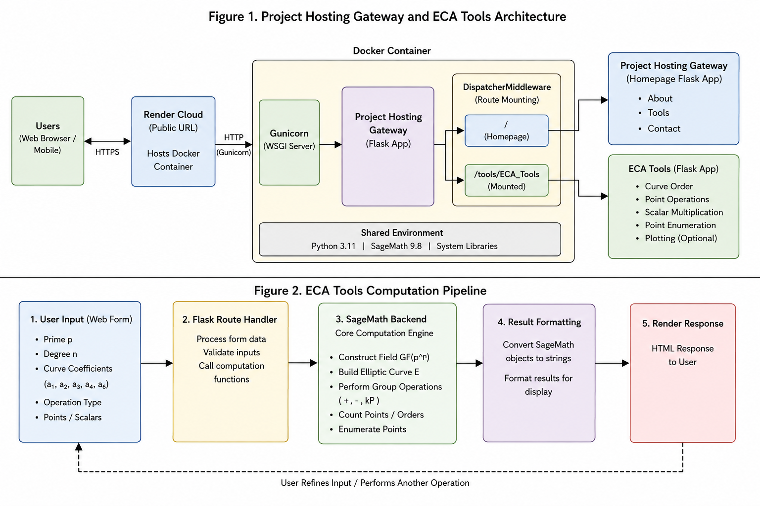
Figure 1. Project Hosting Gateway and ECA Tools architecture diagram

Repository / Folder | Purpose
BE_Project/2026/ECA_Tools | Academic copy: ECA WebApp, SageMath scripts, Docker config, documentation
Project_Hosting | Standalone gateway with homepage, Tools folder, and Sample template
Project_Hosting/Tools/ECA_Tools | Mounted version of ECA Tools adjusted for route-prefix awareness
Project_Hosting/Tools/Sample | Starter template for future tool groups; copy-rename-mount workflow
Table 7. Project repository map
Werkzeug DispatcherMiddleware in Project_Hosting/app.py receives every request and dispatches by prefix: ‘/’ goes to the homepage Flask app, and ‘/tools/ECA_Tools’ goes to the ECA Tools Flask app. The gateway uses os.environ[“TOOLS_PREFIX”] = “/” to signal each tool that it is running under a subpath. Inside the tool, request.script_root provides the mount prefix so all form actions and navigation links remain correct.

4.2 ECA Tools Application
The Flask application (app.py) defines routes for the home page, credits page, static CSS, curve order, point listing, point addition, point subtraction, point multiplication, and GET-redirect fallbacks. Each POST route reads form data, builds a SageMath subprocess command using helper functions curve_coeffs_from_form and build_point_command, and calls _run_managed_command.
Figure 2. ECA Tools computation pipeline

Script | Operation | Important Inputs | Output
find_Curve_Order.py | Curve order and generator info | p, n, coeff choice, a₁–a₆ | Curve order, prime-order flag, generator points
List_Elliptic_Curve_Pts_N_Ordrs.py | List all points and orders | p, n, coefficients | All (x,y) points and individual point orders
Point_Add.py | Point addition P + Q | Coefficients, P = (x₁,y₁), Q = (x₂,y₂) | Result P + Q
Point_Substract.py | Point subtraction P − Q | Coefficients, P, Q | Result P − Q
Point_Multiply.py | Scalar multiplication k·P | Coefficients, P, scalar k | Result k·P
webapp_helpers.py | Helper layer | Form values, plot flags, random seed | Random coefficients, result fragments, base64 plots
Table 8. SageMath backend script map
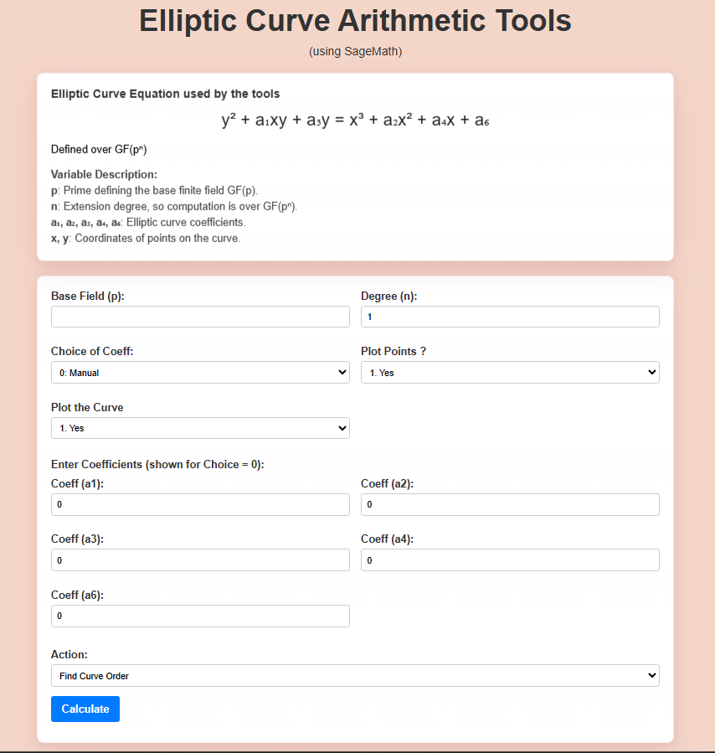
Figure 3. ECA Tools Home Page
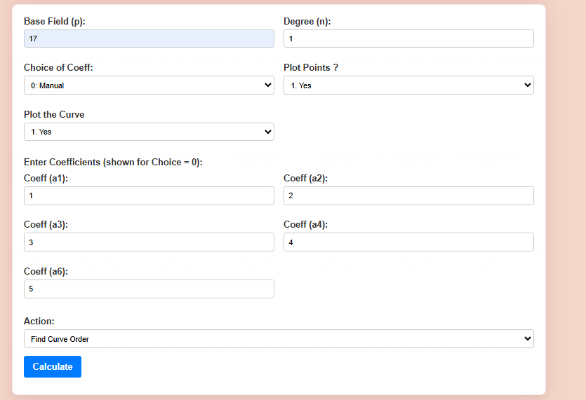
Figure 4. Curve Order Input Form
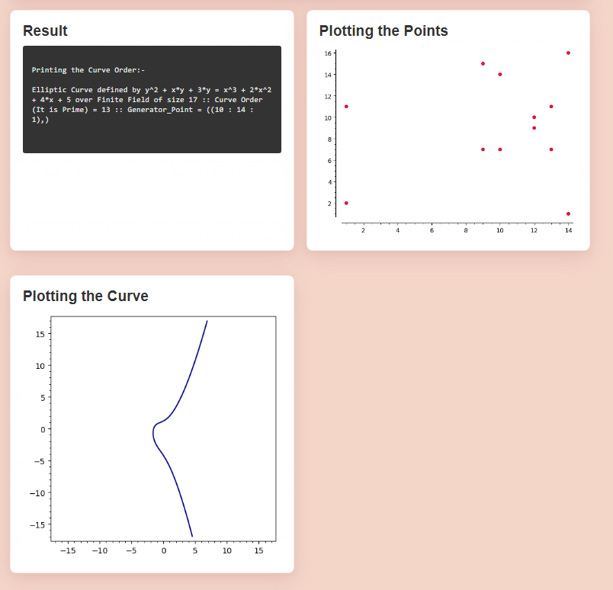
Figure 5. Curve Order Result Page
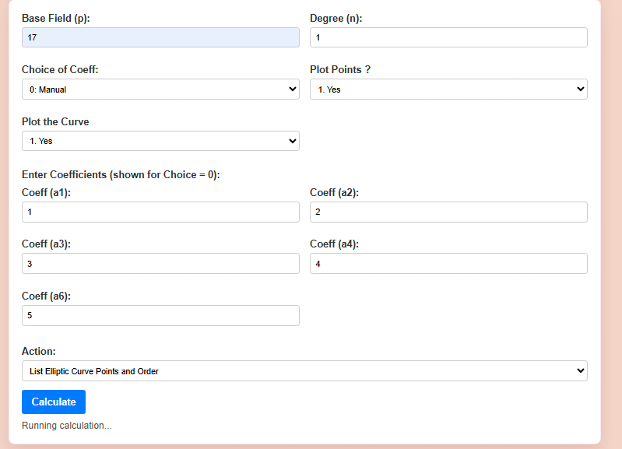
Figure 6. Elliptic Curve Points and Order Input Form
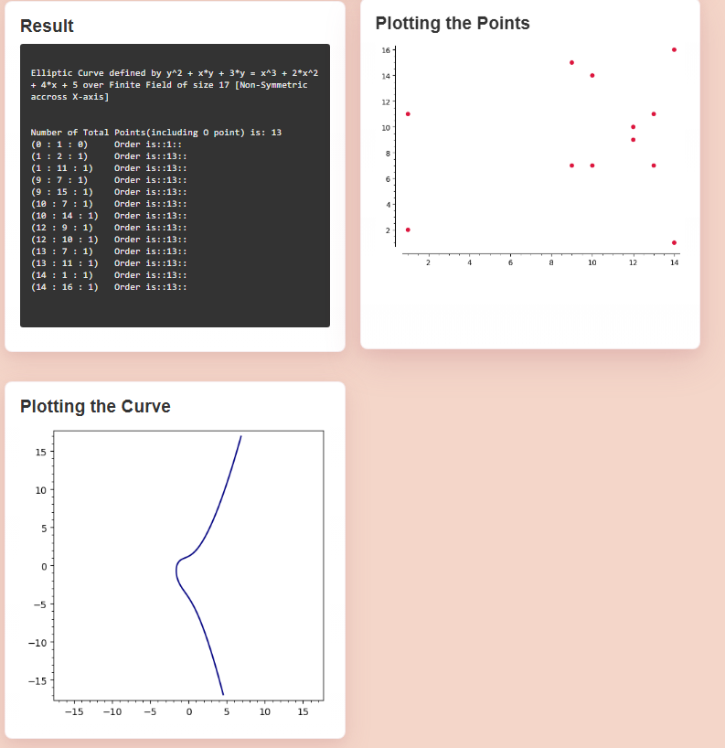
Figure 7. Elliptic Curve Points and Order Output
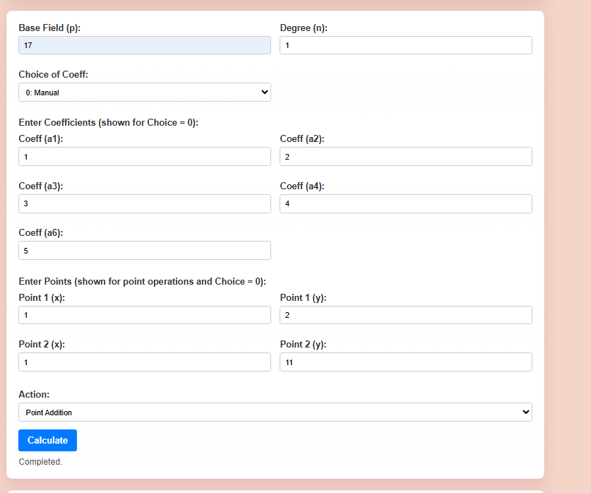
Figure 8. Point Addition Interface
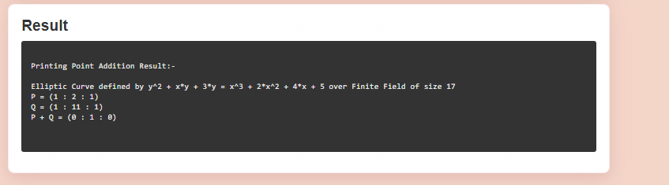
Figure 9. Point Addition Result
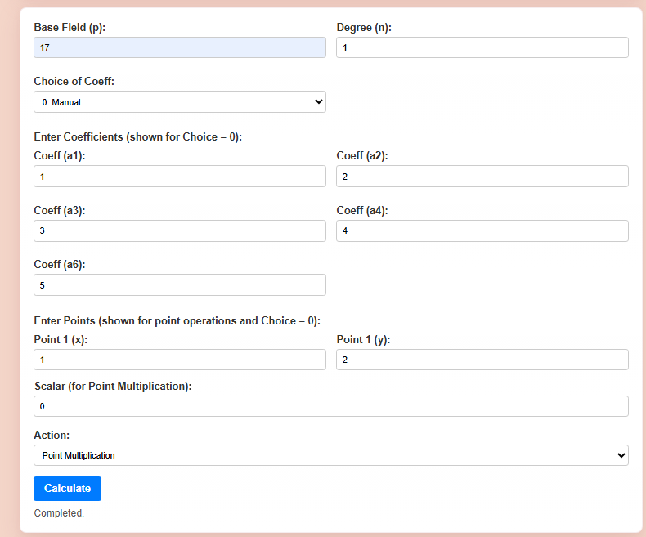
Figure 10. Scalar Multiplication Interface
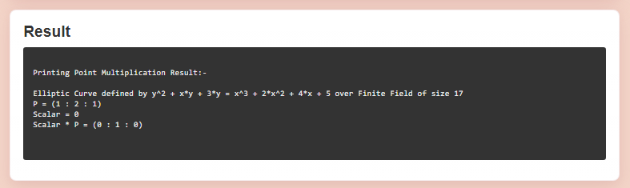
Figure 11. Scalar Multiplication Result

4.3 Request Management
SageMath operations can be computationally expensive, particularly full point listing or curve-order computation over large extension fields. The application maintains a dictionary _ACTIVE_REQUESTS keyed by a ‘request scope’ string combining the client identifier (from the X-Client-Id header or the remote address) and the operation name.
When the same client submits a new request for the same operation, any currently running subprocess for that scope is terminated before the new one is launched. Each subprocess is also protected by a 120-second timeout enforced through subprocess.communicate(timeout=120). If the timeout fires, a TimeoutExpired exception is caught, the process is killed, and an informative error message is returned to the user.

4.4 Sample Computation: Curve over GF(17)
For the short Weierstrass curve y² = x³ + 3x + 14 over GF(17), encoded as general Weierstrass with [a₁, a₂, a₃, a₄, a₆] = [0, 0, 0, 3, 14], the system returns the following:
- Curve order: 18 (17 affine points + the point at infinity O)
- Generator points are identified as those with point order equal to 18
- Complete point listing with individual point orders is returned for all 17 affine points
- Point arithmetic operations (addition, subtraction, scalar multiplication) produce results consistent with the group law verified manually
The same curve parameters serve as the baseline test case for all functional tests in Table 9.

4.5 Functional Testing
Test Case | Input / Action | Expected Result | Status
Curve order | GF(17), [0,0,0,3,14] | Curve order 18 returned by E.order() | Pass
Point listing | Valid curve over GF(p) | All 17 points listed with point orders | Pass
Point addition | P=(5,1), Q=(6,3) over GF(17) | P + Q computed and printed | Pass
Point subtraction | P, Q valid curve points | P − Q computed and printed | Pass
Scalar multiplication | P valid, k=5 | 5·P computed and printed | Pass
Random coefficients | Choice_of_Coeff=1 | Non-singular random curve generated | Pass
Extension field | GF(5²), general Weierstrass | Curve and points over GF(25) | Pass
Mounted route | /tools/ECA_Tools | Home, credits, CSS, forms work | Pass
Plot option | n=1 and plot enabled | Base64 PNG returned in response | Pass
Process timeout | Request longer than 120 s | Timeout error returned; process killed | Pass
Duplicate request | Same client, same op | Previous pending process replaced | Pass
GET redirect | GET to /calculate | Redirects to home page | Pass
Table 9. Functional testing matrix

4.6 Project Hosting Gateway
Project_Hosting/Tools/Sample provides a minimal starting point: a stub Flask app, a trivial SageMath script, and matching HTML/CSS templates that demonstrate correct use of request.script_root. A new group follows three steps:
- Copy Tools/Sample to Tools/<NewToolName> and implement the new tool logic.
- In the gateway app.py, add one import and one DispatcherMiddleware entry under /tools/<NewToolName>.
- Add a navigation link from the homepage to /tools/<NewToolName>.
No changes to existing tool code or the core gateway are required. The Sample tool’s README documents these three steps in detail.
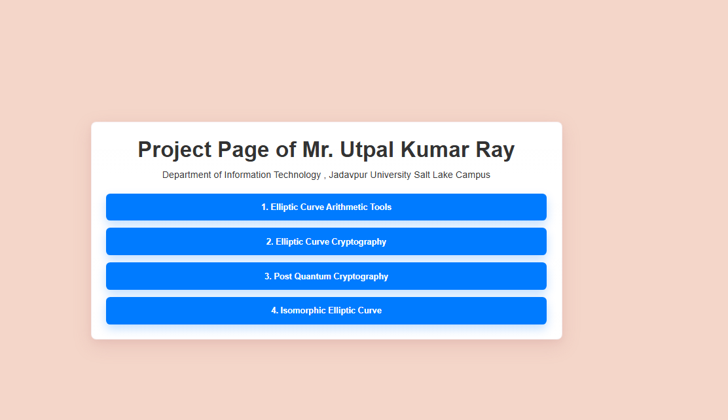
Figure 12. Project Hosting Home Page
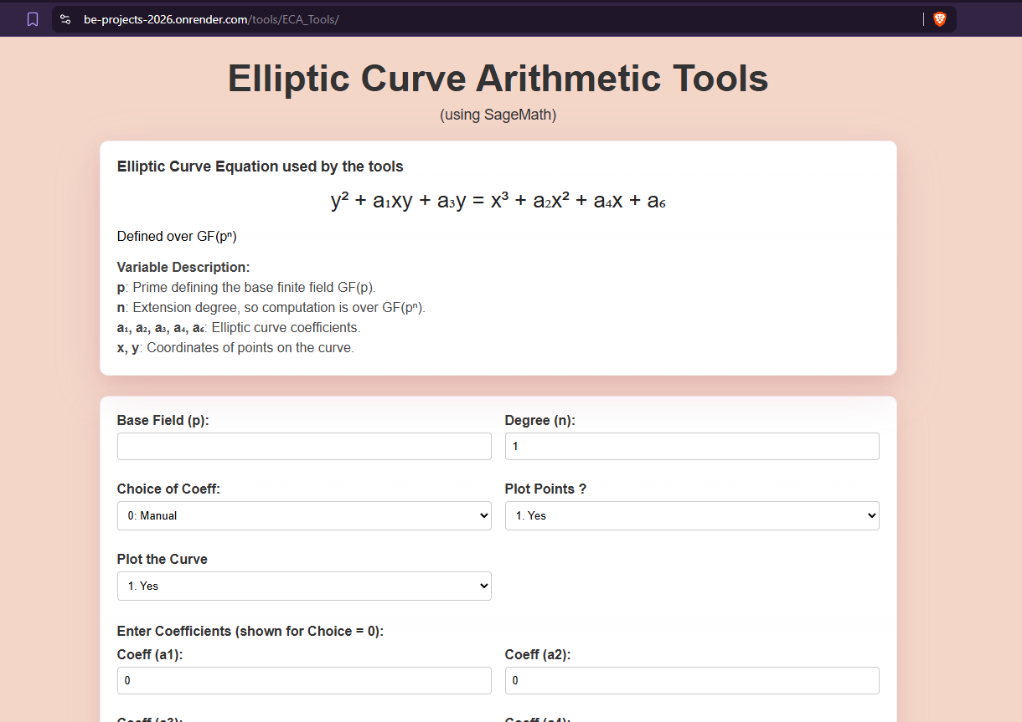
Figure 13. Mounted ECA Tools Through Gateway

5. Performance Analysis
Scenario | Observed Behaviour | Design Response
Small prime fields (p < 100) | Interactive sub-second response | Suitable for classroom demonstrations
Medium prime fields (p ~ 10³) | Curve order: fast; point listing: a few seconds | Acceptable for web use; no timeout triggered
Large prime fields (p > 10⁵) | Point listing expensive; order fast (SEA algorithm) | 120-second timeout guards the web service
Extension fields (n > 1) | More expressive but potentially slower | Delegated entirely to SageMath for correctness
Concurrent duplicate requests | Stale SageMath processes accumulate | Request-scope replacement terminates prior process
Plotting | Meaningful only for n = 1 fields | Plot flag restricted to degree-one fields in UI
Container cold start | SageMath image is large (∼2 GB) | Docker keeps environment reproducible; Render restarts on demand
Table 10. Performance and deployment observations
Point addition, subtraction, and scalar multiplication are fast for all field sizes because SageMath reduces these to a fixed number of field operations. Curve order and full point listing scale with the field size and extension degree. For p ~ 10³ the curve-order call is sub-second; full point listing at that scale returns within a few seconds. The 120-second timeout is sufficient for meaningful classroom examples across all tested configurations.

6. Boundaries of Current Work
The tool is educational and demonstrational. It is not intended to replace audited, constant-time cryptographic libraries such as OpenSSL, BouncyCastle, or libsodium for production use.
Plotting is limited to degree-one fields (n = 1) because extension-field elements do not have a natural two-dimensional real-plane representation. The degree-two and higher cases produce algebraic structures where visualisation requires non-trivial projections that are outside the current scope.
Very large finite fields (p > 10⁶ with full point listing requested, or high extension degrees) may exceed the 120-second web service timeout on the hosted container. Users working with such parameters are advised to run ECA Tools locally with Docker where there is no service-level timeout.
Future tools currently require a manual import and DispatcherMiddleware entry in the gateway app.py. Automatic folder discovery, while desirable, is not yet implemented.
The deployment uses Render’s free tier, which may impose cold-start latency (typically 30 – 90 seconds) after periods of inactivity due to the large SageMath container image.

7. Conclusion
This project successfully delivers two academic contributions. ECA Tools provides a browser-accessible interface for exact elliptic-curve arithmetic over both prime and extension fields, powered by SageMath and containerised with Docker for reproducible deployment. The tool validates against the general Weierstrass curve form, handles all five basic operations, and manages concurrent SageMath subprocesses through a request-scoping and timeout mechanism.
Project Hosting provides a reusable pattern for mounting independent Flask tools under a common homepage gateway. The DispatcherMiddleware architecture isolates tools, and the Sample template lets future groups add a working tool with minimal friction.
Both repositories are live: ECA Tools standalone at https://be-projects-2026.onrender.com, with the Project Hosting gateway at the same address serving the gateway-mounted version at /tools/ECA_Tools. The project demonstrates that SageMath’s mathematical depth and Flask’s web simplicity complement each other effectively for academic tool development, and that Werkzeug DispatcherMiddleware is a clean, low-overhead solution to the multi-tool hosting problem.

8. Future Scope
The following extensions are identified as natural next steps:
- Automatic discovery and mounting of tool folders from Project_Hosting/Tools without manual gateway modification.
- Asynchronous job queues (e.g., Celery with Redis) for expensive SageMath computations, with live progress feedback in the browser.
- Downloadable PDF or DOCX result reports for individual user computation runs.
- ECDLP demonstrations: given G and Q = kG over a small field, recover k by brute force or baby-step giant-step.
- Cryptographic protocol simulations: ECDH key exchange and ECDSA signature schemes demonstrated interactively.
- Improved algebraic visualisation for extension-field elements using projection or embedding techniques.
- Role-based access control and session logging if the gateway is used for formal laboratory submissions.
- Integration with a CI/CD pipeline so that approved student pull requests to BE_Projects are automatically mirrored into Project_Hosting.

Appendix I: How to Add a New Tool in Project Hosting
The Project Hosting repository has been designed as a centralized gateway for hosting multiple academic tools developed by different project groups. Instead of deploying each application independently, tools can be mounted under a common homepage using Werkzeug DispatcherMiddleware. This approach provides a unified user experience while allowing each tool to remain an independent Flask application.
I.1 Overview
The repository contains a dedicated Tools directory. Each subfolder within this directory represents a separate project. The gateway application routes incoming requests to the appropriate tool based on the URL path.

Example:
URL Path | Tool
/ | Project Hosting Homepage
/tools/ECA_Tools | Elliptic Curve Arithmetic Tools
/tools/Sample | Demonstration Tool
/tools/NewTool | Future Project

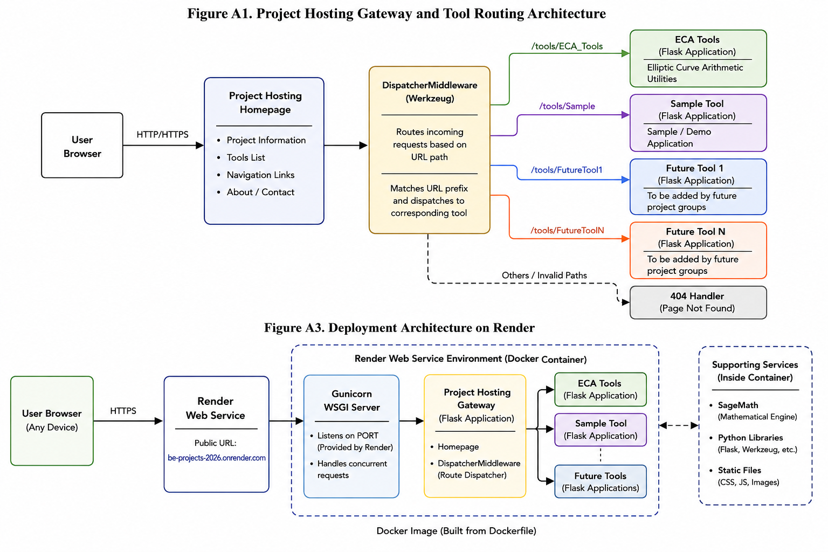
Figure A1. Project Hosting Gateway and Tool Routing Architecture

I.2 Creating a New Tool
To add a new tool, create a copy of the Sample template.
cp -r Tools/Sample Tools/NewTool
The copied folder already contains:
NewTool/
├── app.py
├── webapp_helpers.py
├── scripts/
├── templates/
├── styles/
└── README.md
The developer may replace the sample logic with project-specific functionality while preserving the overall folder structure.

I.3 Flask Application Requirements
Every tool must expose a Flask application object named app.

Example:
from flask import Flask

app = Flask(__name__)

@app.route("/")
def home():
return "Hello from New Tool"
The gateway imports this application and mounts it under a URL prefix.

I.4 Registering the Tool
Open Project_Hosting/app.py and import the application:
from Tools.NewTool.app import app as new_tool_app
Add the tool to DispatcherMiddleware:
application = DispatcherMiddleware(
homepage_app,
{
"/tools/NewTool": new_tool_app
}
)
This automatically makes the tool accessible through:
https://be-projects-2026.onrender.com/tools/NewTool

I.5 Homepage Integration
Add a navigation entry to the homepage template:
<a href="/tools/NewTool">
Open New Tool
</a>
The new project will then appear in the list of available tools.

I.6 Testing the Integration
Run the gateway locally:
docker compose up
or
python app.py

Verify that:
- Homepage loads successfully.
- New tool appears in navigation.
- URL routing functions correctly.
- Static files are accessible.
- Form submissions operate as expected.

The modular architecture ensures that future student projects can be added with minimal changes to the core hosting infrastructure.

Appendix II: Deployment of Project Hosting on Render
The Project Hosting Gateway and ECA Tools are deployed using Render, a cloud platform that supports Docker-based web applications. Containerization ensures reproducibility across development, testing, and production environments while simplifying deployment of SageMath-based applications.

II.1 Deployment Architecture
The deployment architecture consists of four major components:
1. User Web Browser
2. Render Cloud Platform
3. Gunicorn WSGI Server
4. Flask Applications (Project Hosting and ECA Tools)
Figure A3. Deployment Architecture on Render

Request flow:
- User Browser
  - Render Web Service
    - Gunicorn
      - Project Hosting Gateway
        - Homepage
        - ECA Tools

II.2 Docker-Based Deployment
The application is containerized using Docker.
Example Docker build command:
docker build -t be-projects .
Running locally:
docker run -p 5000:5000 be-projects
The Docker image contains:
- Python Runtime
- SageMath
- Flask
- Werkzeug
- Gunicorn
- Application Source Code
This guarantees identical behaviour across different machines.

II.3 Render Configuration
The deployment uses the following configuration:
Parameter | Value
Platform | Render
Service Type | Web Service
Runtime | Docker
Build Method | Docker Build
Server | Gunicorn
Framework | Flask
Deployment | Automatic
The service is automatically rebuilt whenever changes are pushed to the connected repository.

II.4 Public Deployment
The current public deployment URL is:
https://be-projects-2026.onrender.com/
This URL hosts the Project Hosting Gateway and all mounted tools.
The ECA Tools application is accessible through:
https://be-projects-2026.onrender.com/tools/ECA_Tools
The gateway architecture allows future tools to be integrated without requiring separate public deployments.
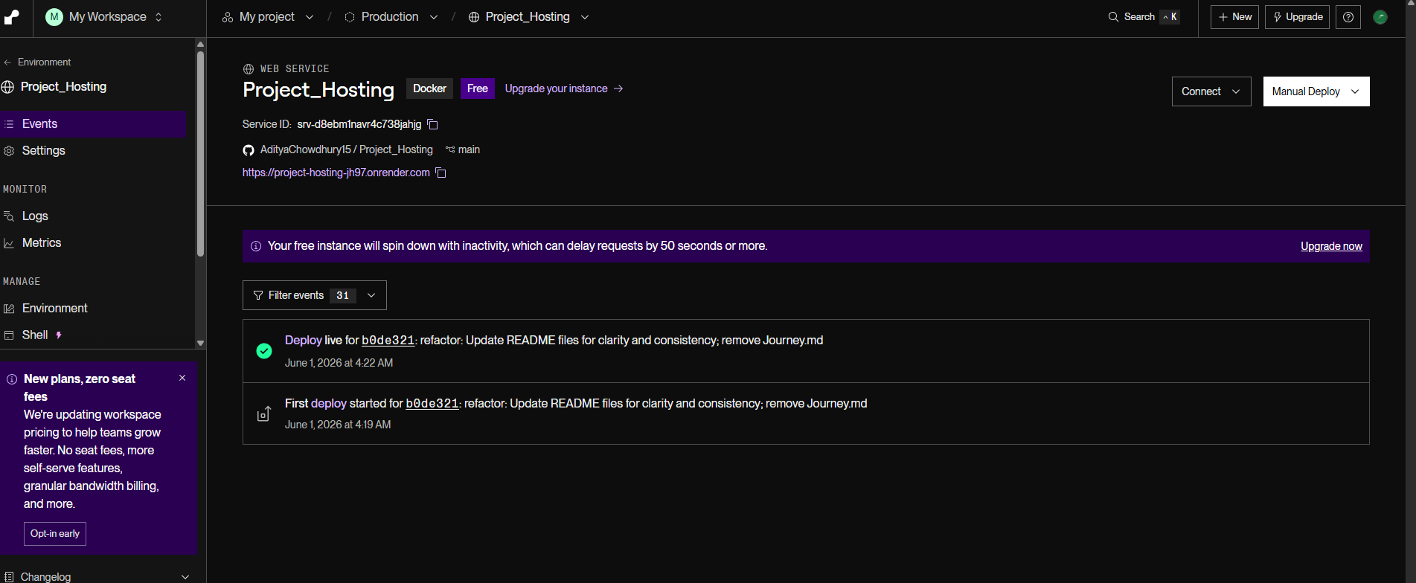
Figure A4. Project Hosting Homepage on Render

II.5 Deployment Challenges
Several practical deployment challenges were encountered during implementation. However, the most significant one is:
- Large SageMath Image
The SageMath runtime significantly increases Docker image size. Large images require longer build and deployment times.

- Cold Start Delays
Render may suspend inactive services on free-tier deployments. The first request after inactivity can experience startup delays.
- Long Running Computations
Elliptic curve point enumeration and order calculations may take significant computation time for large fields.

To prevent resource exhaustion, the application implements:
process.communicate(timeout=120)
This enforces a maximum execution time of 120 seconds.

Route Prefix Awareness
Since ECA Tools is mounted under a subpath, the application uses:
request.script_root
to generate correct URLs for forms, navigation links, and static resources.

II.6 Deployment Benefits
The deployment architecture provides:
- Centralized hosting
- Reproducible execution environment
- Easy onboarding of future projects
- Simplified maintenance
- Public accessibility for demonstrations and academic use

Appendix III: Sagemath Installation and Basic Elliptic Curve Commands
SageMath is an open-source mathematical software system that provides extensive support for finite field arithmetic, algebraic structures, and elliptic curve computations. In this project, SageMath serves as the computational backend for all elliptic curve operations performed through the web interface.

III.1 Installing SageMath
On Ubuntu Linux, SageMath can be installed using:
conda create -n sage sage python=3.11
Verify installation:
sage --version
Expected output:
SageMath version 10.8

III.2 Starting SageMath
Launch the SageMath shell:
sage
Interactive computations can then be performed directly.

III.3 Creating Finite Fields
Prime field:
F = GF(17)
This creates the finite field GF(17) containing 17 elements.
Extension field:
F = GF(5^2)
This creates the field GF(25), consisting of 25 elements represented using polynomial arithmetic.

III.4 Creating an Elliptic Curve
The project supports the general Weierstrass form:
y² + a₁xy + a₃y = x³ + a₂x² + a₄x + a₆
Curve construction:
F = GF(17)
E = EllipticCurve(F,[0,0,0,3,14])
This corresponds to:
y² = x³ + 3x + 14

III.5 Computing Curve Order
The order of an elliptic curve is the total number of points on the curve including the point at infinity.
Command:
E.order()
Example:
18
This operation forms the basis of the Curve Order module implemented in ECA Tools.

III.6 Listing Curve Points
All points on the curve can be enumerated using:
E.points()
Sample output:
[(0,5), (0,12), (1,4), ...]
Each point belongs to the elliptic curve group defined over the finite field.

III.7 Point Operations
Define points:
P = E(5,1)
Q = E(6,3)
Point Addition:
P + Q
Point Subtraction:
P - Q
Scalar Multiplication:
5 * P
These commands directly correspond to the operations available in the ECA Tools web application.

III.8 Point Order and Generator Detection
The order of a point is computed using:
P.order()
A generator point satisfies:
P.order() == E.order()
Such points generate the entire elliptic curve group and are important in elliptic curve cryptography.

III.9 Mapping Between ECA Tools and SageMath
ECA Tools Function | SageMath Command
Curve Order | E.order()
Point Listing | E.points()
Point Addition | P + Q
Point Subtraction | P - Q
Scalar Multiplication | k * P
Point Order | P.order()
Generator Check | P.order() == E.order()

The ECA Tools application invokes these SageMath operations through managed subprocesses and presents the results through a browser-based interface, thereby providing an educational platform for studying elliptic curve arithmetic without requiring direct interaction with SageMath.
References
[1] V. S. Miller, “Use of Elliptic Curves in Cryptography,” CRYPTO 1985, Lecture Notes in Computer Science, Vol. 218, Springer, pp. 417–426, 1986.
[2] N. Koblitz, “Elliptic Curve Cryptosystems,” Mathematics of Computation, Vol. 48, No. 177, pp. 203–209, 1987.
[3] J. H. Silverman, The Arithmetic of Elliptic Curves, Graduate Texts in Mathematics, Springer, 1986.
[4] L. C. Washington, Elliptic Curves: Number Theory and Cryptography, 2nd ed., Chapman and Hall/CRC, 2008.
[5] SageMath Developers, SageMath, the Sage Mathematics Software System. [Online]. Available: https://www.sagemath.org
[6] A. J. Menezes, P. C. van Oorschot, and S. A. Vanstone, Handbook of Applied Cryptography, CRC Press, 1996.
[7] Pallets Projects, Flask Documentation. [Online]. Available: https://flask.palletsprojects.com
[8] Pallets Projects, Werkzeug Documentation — DispatcherMiddleware. [Online]. Available: https://werkzeug.palletsprojects.com
[9] Docker Inc., Docker Documentation. [Online]. Available: https://docs.docker.com
[10] Render, Web Service Deployment Documentation. [Online]. Available: https://render.com/docs
[11] C. Bach, “Elliptic Curve Calculator,” [Online]. Available: http://christelbach.com/ECCalculator.aspx, 2010.
[12] Dr. S. Grau, “ECC Visualiser Tool,” [Online]. Available: https://graui.de/code/elliptic2/, 2011–2017.

